## Introduction

The Big Mountain Resort (BMR) was seeking to evaluate a new ticket price adjusted by modern data science methods. Based on an evaluation of provided data provided by the BMR database manager, Alesha Eison, it was found that an increase of $8.61 per ticket (for a new total of $89.61), an overall ~$15,065,471 seasonal revenue, could be achieved by adding one additional run and chairlift to increase the vertical drop by 150 feet. This would recoup the approximate 1.5-million-dollar operations costs within a year, in addition to the added costs of the recommended additions. The removal of a run should instead not affect the ticket price, but anymore than 5 closed runs would lead to a steeper drop (Figure A).

## Background

A combination of Python 3.8.5 and related packages (pandas, nympy, os, pickle, motplotlib, seaborn, sklearn) were used to come to these conclusions. The weekend price data was used for this modeling. A single price column was generated after observations showed little differences in weekend versus weekday price in our target market. The data set was expunged of resorts missing weekend pricing data, as it was a target feature for analysis.

More data was not required to come to these conclusions. It was observed that 193 resorts were in the training set, and 83 in the test set. As seen in Figure B, the minimum sample size for cross-validated data is 40-50 resorts. The assumption made for these pricing models included visitors buying an average of 5 day-tickets.

There were 22 numerical and 3 object categories. 1 Categorical feature was added called ‘Quartile’. This was used to separate prices into quartiles for easier visualization. Ticket prices were not directly affected by the state, but features of the state such as total size, skiable area, and state population were. This led to further exploring these features by determining relative ratios and creating a new data frame that only contained resorts_per_100kcapita, resorts_per_100ksq_mile, resort_skiable_area_ac_state_ratio, resort_days_open_state_ratio, resort_terrain_park_state_ratio, resort_night_skiing_state_ratio, total_chairs_runs_ratio, total_chairs_skiable_ratio, fastQuads_runs_ratio, and fastQuads_skiable_ratio. A scatterplot was used to compare numeric features within a matrix. More of any one feature (e.g. fastQuads) may initially seem beneficial, but it appeared instead a minimum number of them was required for a baseline price (0 available equated to lower prices on average).

## Results

Based on results, a combination of adding 1 additional run, increasing vertical drop by 150ft, and installing 1 additional chairlift would be best. Increased the snow making area in addition to these changes yielded less than a dollar increase in projected ticket price. The operating costs to add two additional acres of snow making machines for the vertical drop would be higher than the projected value.

Closing runs to save costs was also explored. No ticket price difference is expected when closing 1 run. Closing 3 has the same effect as 5, but any more than that may lead to a sharp decrease in revenue on those days. (Figure A) The operating costs of another run and chair lift would need to be analyzed, but unlikely to be more than the expected seasonal revenue of $ 15,065,471.

Based on these finding, the following is recommended:

* A ticket price increase of approximately 9 dollars, for a new total price of 90 dollars, would be recommended.
* Increase total vertical drop of resort by 150 feet.
* Add one additional run and chairlift on the new vertical drop.

Appendices

Figures

**Figure A:**

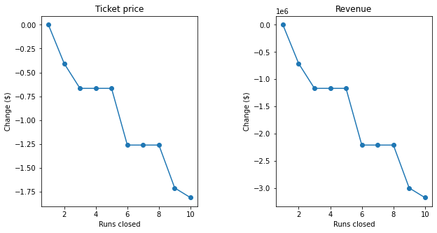

**Figure B:** 